**Handout Review Introduction to Linux**

1. Use the provided website link to answer the following questions:
   1. What is the difference between the Kernel and an Operating System? [Kernel](https://en.wikipedia.org/wiki/Kernel_(operating_system))

**Think of it this way**:

*A*kernel*is the part of the operating system that mediates access to system resources. It's responsible for enabling multiple applications to effectively share the hardware by controlling access to CPU, memory, disk I/O, and networking.*

*An*operating system*is the kernel plus system utilities that enable users to get something done (i.e compiler, text editor, window manager, etc).*

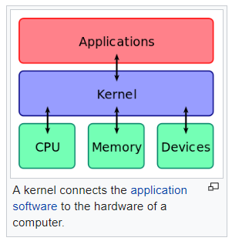

* 1. What is the difference between a microkernel and monolithic kernel? [Micro kernel and Monolithic Kernel](https://simple.wikipedia.org/wiki/Kernel_(computer_science)), [Micro kernel and Monolithic Kernel 2](https://stackoverflow.com/questions/4537850/what-is-difference-between-monolithic-and-micro-kernel)
     1. List 2 pros and cons of each
     2. What type of kernel does Linux use?
  2. What is difference between preemptive and cooperative multitasking? [Cooperative and preemptive multitasking](https://en.wikipedia.org/wiki/Cooperative_multitasking)
  3. What is the difference between “free” and open source software? [Open Source vs Free Software](https://resources.whitesourcesoftware.com/blog-whitesource/what-is-the-difference-between-open-source-and-free-software)
     1. TiVo Digital recorder uses executable (binary) derived from Open Source software that cannot be modified the end user? T/F
     2. What was the purpose of the Open Source Movement?
  4. Provide two examples of productivity software? [Linux Productivity Software](https://www.linuxlinks.com/productivitytools/)
     1. What is Evolution?
     2. What is GNOME?
     3. What is samba? [Samba](https://www.samba.org/samba/what_is_samba.html)